Ideation Phase
Empathize & Discover
Date | 12 July 2026
Team ID | [Enter Team ID]
Project Name | Smart Lender – Loan Approval Prediction System
Maximum Marks | 4 Marks

Empathy Map Canvas
An empathy map captures what the primary user of Smart Lender — a credit officer responsible for approving or declining loan applications — thinks, feels, sees, says, and does today, before an ML-based decision aid exists. Understanding this perspective grounded every downstream design decision, from the single-screen intake form to the confidence gauge on the result page.
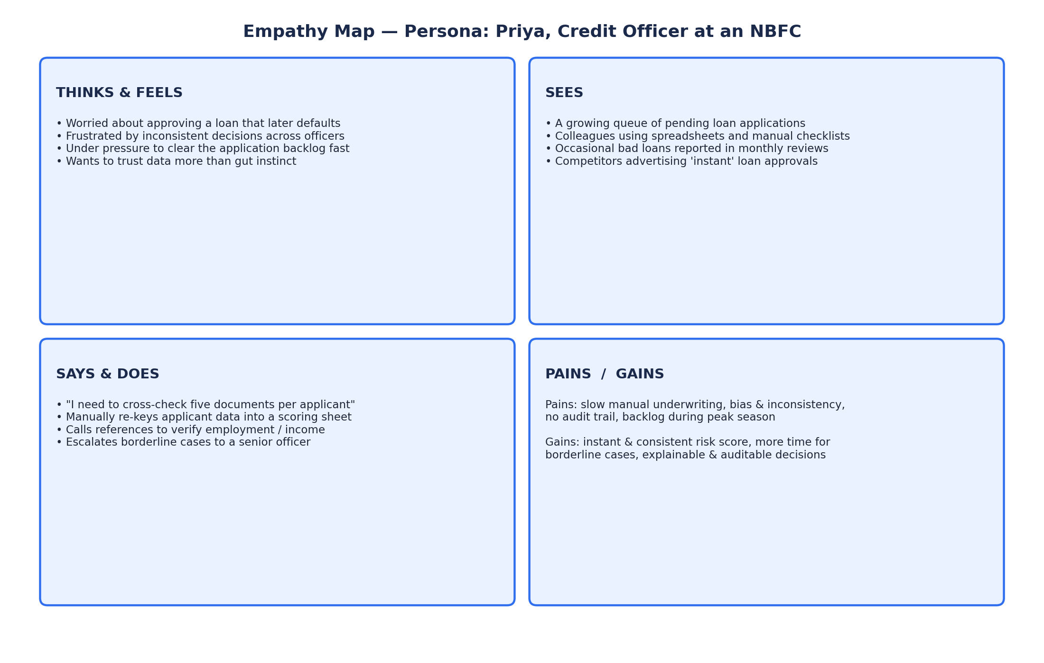

Key takeaways used to shape the solution
- The officer's biggest pain is inconsistency and speed, not a lack of data — Smart Lender must turn data already being collected into an instant, repeatable score.
- Trust matters as much as accuracy: the result page shows a confidence percentage and gauge rather than a bare yes/no, so the officer can judge borderline cases themselves.
- Auditability is a gain the officer explicitly wants — the trained model and comparison metrics (model_comparison.json) are persisted so every decision can be traced back to a known model version.

